

INVENTORY MANAGEMENT SYSTEM WITH PYTHON

Contents

1 Purpose 3

2 Prerequisites to run the POC Set up 3

3 Anaconda Installation 3

4 How to run Python code in Anaconda..................................................................................8

1. **Purpose**

* Inventory management systems in general track goods through the entire supply chain or the portion of it a business operates in.
* That covers everything from production to retail, warehousing to shipping, and all the movements of stock and parts between.
* By tracking the work you’re doing and the materials required to produce that work, you, well, make money

1. **Prerequisites to run the POC Set up**

* The following are the pre-requisites for the configuration:

|  |  |
| --- | --- |
| * Tool Name | * Version Details |
| * Anaconda | * Anaconda3-5.0.1-Windows-x86_64.exe |
| * Angular | * Angular 6 |
| * Flask | * Flask 1.0 |
| * Mongo DB | * Mongo 3.6 |

1. **Anaconda Installation**
2. Download the setup file from below website.

[**https://www.anaconda.com/download/**](https://www.anaconda.com/download/)

or run **Installer.bat** file which has the required setup file and will check if python is installed or not if not then installtion will continue.

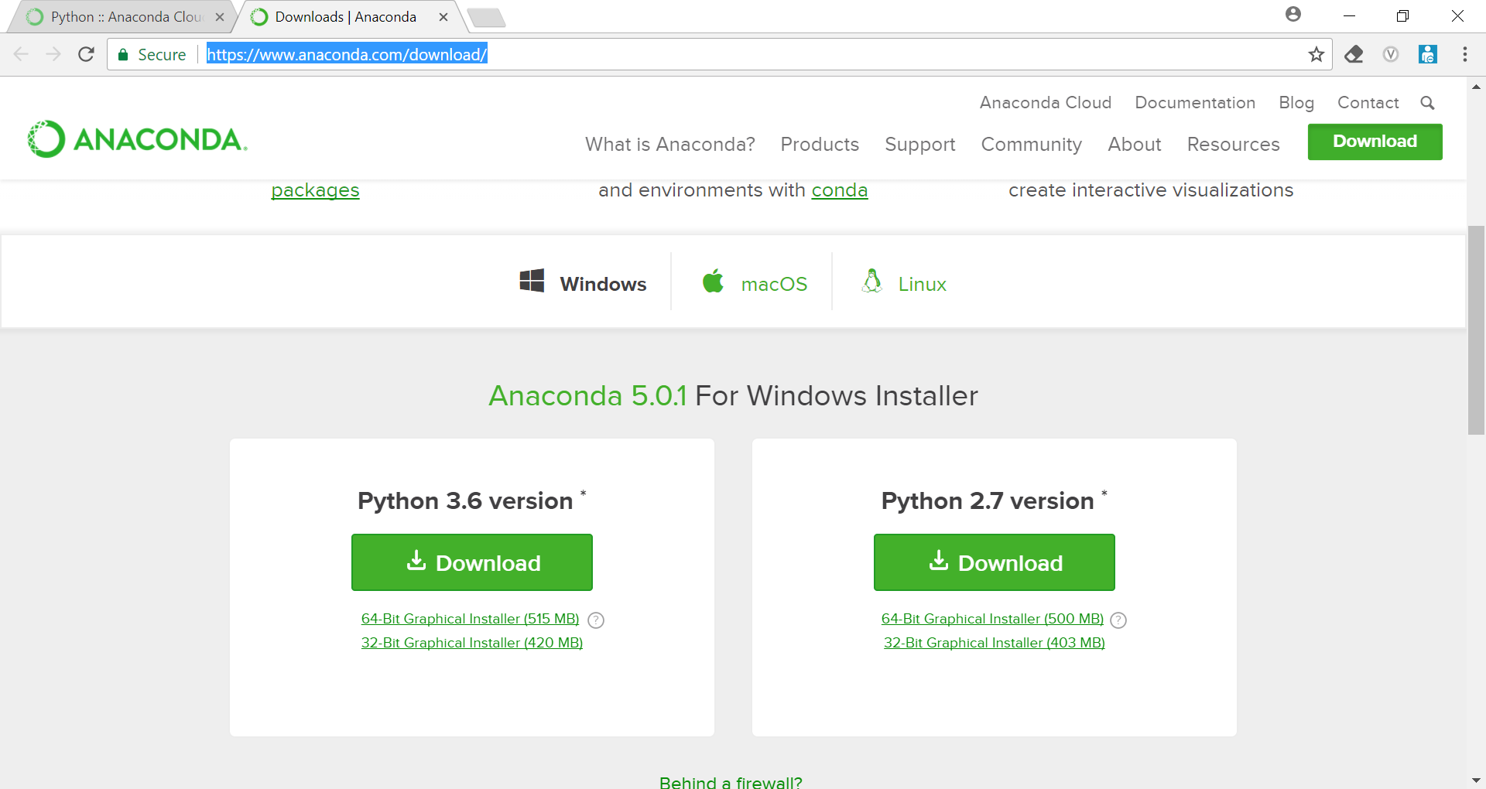

1. Open Anaconda navigator and launch SPYDER (Development environment for python)

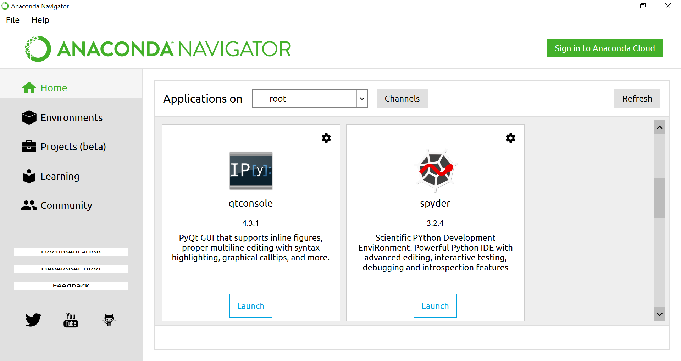

1. Below is the screen shot of spyder environment

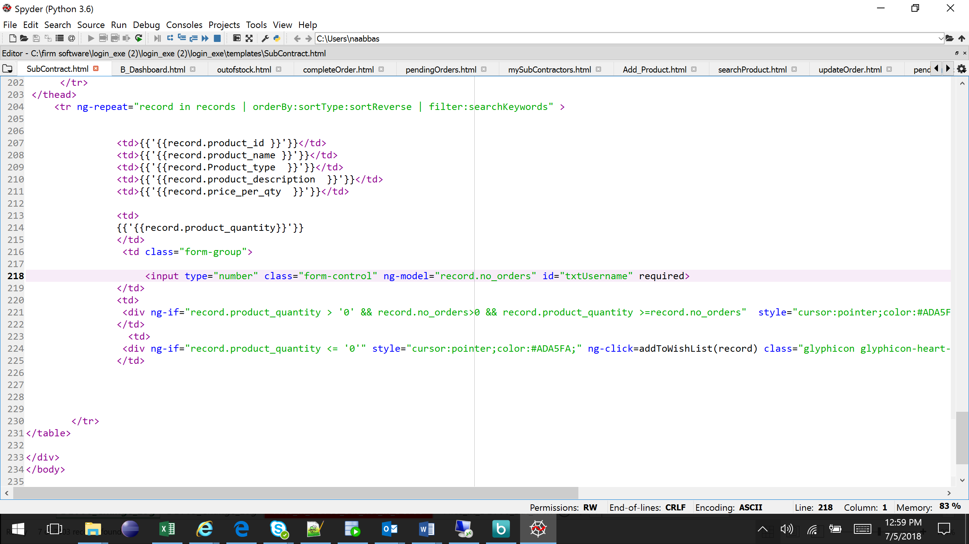

**4.Mongo DB Installation**

**Installation Steps**

## Install MongoDB

### Determine which MongoDB build you need.

There are three builds of MongoDB for Windows:

MongoDB for Windows Server 2008 R2 edition (i.e. 2008R2) runs only on Windows Server 2008 R2, Windows 7 64-bit, and newer versions of Windows. This build takes advantage of recent enhancements to the Windows Platform and cannot operate on older versions of Windows.

MongoDB for Windows 64-bit runs on any 64-bit version of Windows newer than Windows XP, including Windows Server 2008 R2 and Windows 7 64-bit.

MongoDB for Windows 32-bit runs on any 32-bit version of Windows newer than Windows XP. 32-bit versions of MongoDB are only intended for older systems and for use in testing and development systems. 32-bit versions of MongoDB only support databases smaller than 2GB.

To find which version of Windows you are running, enter the following command in the Command Prompt:

wmic os get osarchitecture

### Download MongoDB for Windows.

Download the latest production release of MongoDB from the MongoDB downloads page. Ensure you download the correct version of MongoDB for your Windows system. The 64-bit versions of MongoDB does not work with 32-bit Windows.

### Install the downloaded file.

In Windows Explorer, locate the downloaded MongoDB msi file, which typically is located in the default Downloads folder. Double-click the msi file. A set of screens will appear to guide you through the installation process.

### Move the MongoDB folder to another location (optional).

To move the MongoDB folder, you must issue the move command as an Administrator. For example, to move the folder to C:\mongodb:

Select Start Menu > All Programs > Accessories.

Right-click Command Prompt and select Run as Administrator from the popup menu.

Issue the following commands:

cd \

move C:\mongodb-win32-* C:\mongodb

MongoDB is self-contained and does not have any other system dependencies. You can run MongoDB from any folder you choose. You may install MongoDB in any folder (e.g. D:\test\mongodb)

## Run MongoDB

### Warning:

Do not make mongod.exe visible on public networks without running in “Secure Mode” with the auth setting. MongoDB is designed to be run in trusted environments, and the database does not enable “Secure Mode” by default.

### Set up the MongoDB environment.

MongoDB requires a data directory to store all data. MongoDB’s default data directory path is \data\db. Create this folder using the following commands from a Command Prompt:

md \data\db

You can specify an alternate path for data files using the --dbpath option to mongod.exe, for example:

C:\mongodb\bin\mongod.exe --dbpath d:\test\mongodb\data

If your path includes spaces, enclose the entire path in double quotes, for example:

C:\mongodb\bin\mongod.exe --dbpath "d:\test\mongo db data"

### Start MongoDB.

To start MongoDB, run mongod.exe. For example, from the Command Prompt:

C:\Program Files\MongoDB\bin\mongod.exe

This starts the main MongoDB database process. The waiting for connections message in the console output indicates that the mongod.exe process is running successfully.

Depending on the security level of your system, Windows may pop up a Security Alert dialog box about blocking “some features” of C:\Program Files\MongoDB\bin\mongod.exe from communicating on networks. All users should select Private Networks, such as my home or work network and click Allow access. For additional information on security and MongoDB, please see the Security Documentation.

### Connect to MongoDB.

To connect to MongoDB through the mongo.exe shell, open another Command Prompt. When connecting, specify the data directory if necessary. This step provides several example connection commands.

If your MongoDB installation uses the default data directory, connect without specifying the data directory:

C:\mongodb\bin\mongo.exe

If you installation uses a different data directory, specify the directory when connecting, as in this example:

C:\mongodb\bin\mongod.exe --dbpath d:\test\mongodb\data

If your path includes spaces, enclose the entire path in double quotes. For example:

C:\mongodb\bin\mongod.exe --dbpath "d:\test\mongo db data"

If you want to develop applications using .NET, see the documentation of C# and MongoDB for more information.

### Begin using MongoDB.

To begin using MongoDB, see Getting Started with MongoDB. Also consider the Production Notes document before deploying MongoDB in a production environment.

Later, to stop MongoDB, press Control+C in the terminal where the mongod instance is running.

**5. How to run Python code in Anaconda :-**

* Checkout the project folder from Git repo from below url

<https://github.com/IMSDeloitte/Inventory.git>

* Go to setup/installer folder and run Anaconda_Installer.bat file it will check if python and anaconda is already installed and if not it will install anaconda and python.

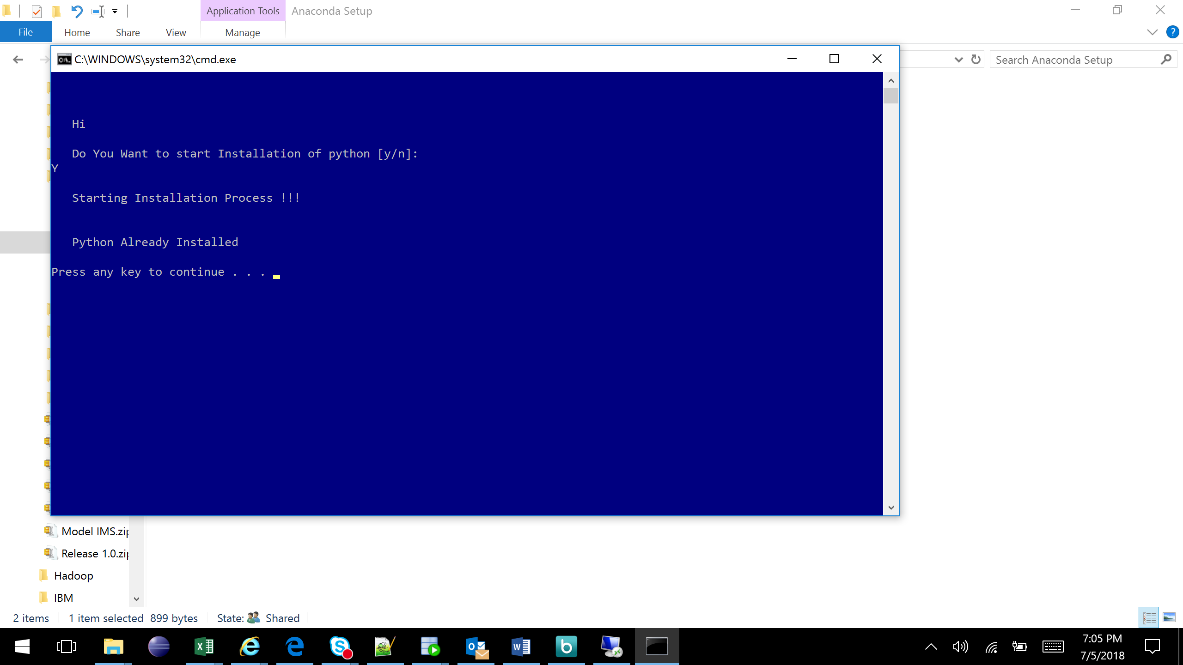

* Now we are ready to do project specific setup.
* Open Library Setup under installer and copy anaconda prompt short cut from your local machine.

Steps : Go to Window >> search Anaconda >> right click >> open file location >> copy anaconda promp short cut to installer/Library Setup folder which you have copied from git repo.

* Run Model_Runner.bat file to install all the required libraries. This batch file will run script to install all the required libraries like Python Flask, PYMONGO,

etc so that we will be ready to run our application.

* Now we are all set to run server go to root project directory and copy anaconda prompt short cut from your local to project root directory.
* Step : Go to Window >> search Anaconda >> right click >> open file location >> Copy anaconda prompt short cut to project root folder which you have copied from Git repo.
* Run run_app.bat file this file will start the server and deploy application to the server .

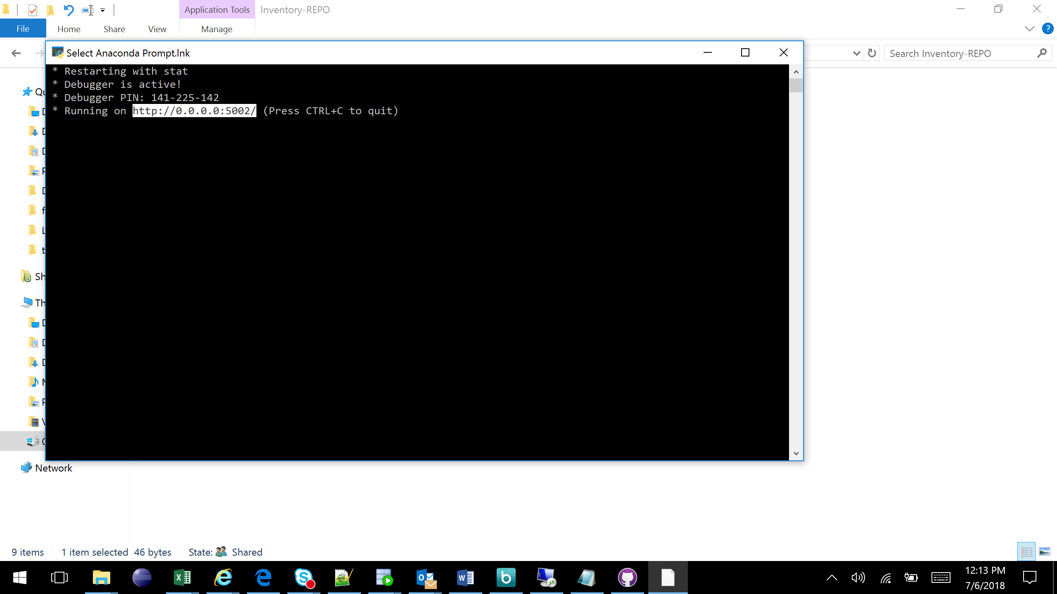

* Copy the server URL and hit it from browser.

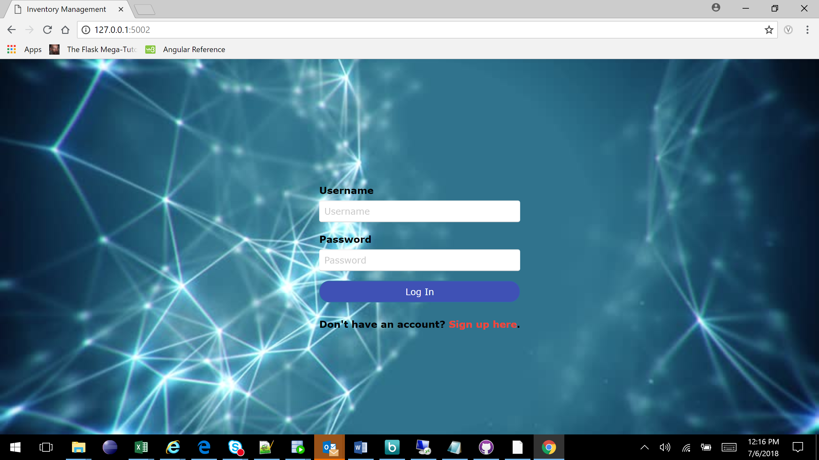

HERE WE GO....!!!!!